SERENITY DRUG TEST KITS
Multi Drug Rapid Test Cup • Fast • Reliable • Simple

99%  ACCURACY | FDA & ISO  CERTIFIED | READY  FOR USE

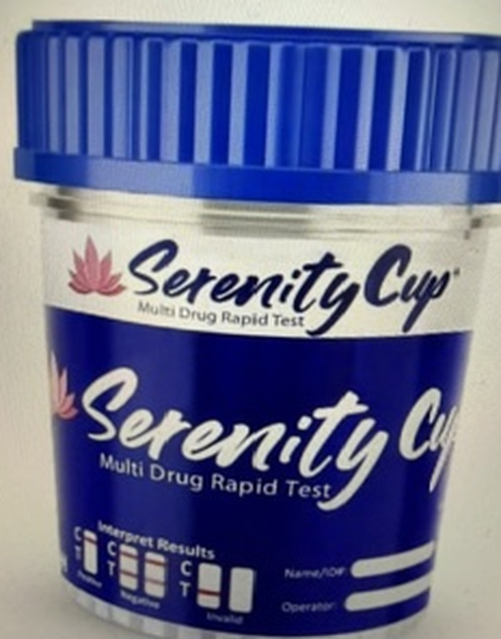  Serenity Cup | Results in 5 Minutes  Delivers a clear, easy-to-read result at the point of collection — no waiting on outside labs.  No Lab Infrastructure Needed  Ideal for schools, clinics, community outreach, and rehabilitation settings with limited resources.  Leak-Proof, Sealed Design  Click-top lid contains the sample safely during collection, handling, and disposal.  Built-In Validity Check  An integrated temperature strip confirms the sample is genuine before results are read.

Accurate on-site screening — anytime, anywhere.

